NAPA VALLEY CRUST
A UNIQUE WINE COUNTRY WOODFIRED CATERING EXPERIENCE
~2024 CONTRACT~

Thank you for choosing Napa Valley Crust to cater your Event!
We will set up 2 hours prior to event. We will serve for approximately 2 hours.
NVC will provide its own 3 tables & linen needed for a Buffet Style Service.
Price includes ALL Biodegradable Disposables (Plates, Forks, Napkins, Cups)
All Parties will include a large Jar of Infused Fruit Iced Water.
Team of 4 chefs included as part of our outstanding Costumer Service!
We will feature a great variety of CLASSIC & GOURMET pizzas options!
*Gluten-free pizzas available upon request! However, for your safety, please know that we’re fully exposed to gluten
*Prices are subject to change when menu and options are customized!

Upgrades Available at Additional cost*
Bamboo dishware, Beer & Wine, Barista, Bar Tender…
*Coffee Service, * Refreshments * Shocked Oysters * Grill Prawns, Pasta, Charcuterrie & more….
A $1000 non-refundable deposit is needed to book and reserve a date.
Please mail a check or ask about Venmo or Zelle or provide credit card info (3% fee to cc)
ALL EVENTS subject to 8% Sales Tax and 20% Service Gratuity
***NVC Catering Minimum is 50 ppl or Chardonnay Pack ($35) X $50= $1750 plus tax & gratuity.
NVC as Vendor will require a $2000 minimum.

NAME_________________________________________________________________________PHONE#_______________________________
EMAIL______________________________________________________________________________# OF GUEST______________________
EVENT ADDRESS______________________________________________________________________________________________________
DATE OF EVENT_______________________________________________________TIME FOR SERVICE_________________________
DEPOSIT $1000~C/C_______________________________________________________Exp_________Sec#______Zip_____________

*Extra Time* Additional Hour of Unlimited Food & Service (if more than 2 hrs is needed)
**(Please check)___________Please Add $5pp. ($400 Minimum)

UNLIMITED BUFFET STYLE-PACKAGE OPTIONS
(Please mark your selection)
**All Packages included Disposables & Infused Citrus-Cucumber Water**

- THE CHARDONNAY….. $35pp_________
Pizza & Salad Pack…3-4 Classic Toppings Pizza Choices, 1 Salad!

- THE MERLOT …..$40pp___________
Same as “The Chardonnay” PLUS 1 regular APPETIZER
Pizza, Appetizer & Salad Pack….5-6 Classic Topping Pizza Choices,1 Salad & 1 Regular Appetizer choice!

- THE RESERVE….. $45pp__________
Pizza, Salad, Appetizer & Piadini Wraps…ALL Pizza Choices,
Larger variety of Classic & Gourmet toppings, 1 Salad, Piadini, 1 Appetizer & S’mores for Dessert!

- THE WEDDING PACKAGE……..$50pp__________
The Works!!! Allow us to show off on your Special Day!
A very nice, full Buffet of ALL Pizza choices, 1 Salad, 1 Appetizer, Fresh Fruit, Cheese & Charcuterrie boards

MENU, OPTIONS, PRICING…

PIZZA
Amazing Wood-fired Pizza! Classic & Gourmet Toppings, Freshest Produce & Specialty Meats
Customize your own choices or Choose from our Selections!

Classic Pepperoni & Cheese-With optional Pesto or Red Sauce_____
Margherita-Mozzarella, Tomatoes, Fresh Basil, Drizzle of Balsamic glaze _____
Veggie Pesto-Roasted Veggies & pesto Sauce toped with fresh tomatoes_____
Spicy Aldo’s-Our Best Seller…Pesto, Pepperoni, Onion, Linguica & Fresh Jalapeños_____
Pesto, Garlic & Baby Clam-A popular options featuring Chef’s Clams mix_____
Garlic Chicken-White Sauce, Grilled chicken, Garlic & Red onions_____
Chicken Pesto & Roasted Corn-With Pesto Sauce, roasted Corn & grilled Chicken_____
Meat Lovers-Salami, Pepperoni, Linguica, Italian Sausage & Bacon_____
Prosciutto, Pear, Arugula-Infused Olive Oil based, topped w hot honey_____
Chef’s Choice! Let the Chef show-off his favorite creations! _____

***Gluten Free crust, Vegetarian and Vegan options available upon request***

SALADS
(One Salad included with ALL Package Choices…Additional Salad @ $5pp)

Classic Caesar-Crispy Romaine Hearts with homemade croutons & Shredded Romano_______
Calistoga Salad-Organic Mixed Greens w/ Cranberries, Walnuts, Tomatoes, cucumbers & Balsamic_______

APPETIZERS
(One Appetizer Inlcuded in ALL Packages EXCEPT in “Chardonnay” Additional Appetizer @ $5pp)

Caprese Skewers -Fresh Mozzarella, Grape Tomatoes & Fresh basil with Balsamic Glaze....$5pp________
Buffalo Wings-Wonderful Oven-baked Chicken Wings served with our own Ranch….$5pp _______
Piadini Bar- Thin Flat Bread Wraps w/Olive oil & garlic, Pizza topping & greens…$5pp________
Bruschetta Bites-Toasted Crostini with cheese & Marinated Tomatoes…$5pp_______
Fresh Fruit Platters – Seasonal Fresh Fruit Platters….$5pp_______

SPECIALTY OPTIONS
CHARCUTERRIE, PIADINE, SHOCKED OYSTER BAR, PASTA & PR AWN-VEGGIE SKEWERS

Charcuterie & Cheese Boards, Prawns Skewers, Oyster Bar, Meat Balls, Pasta, BBQ Sliders & More!
NEW~ Meat Balls tossed in homemade Marinara Sauce, topped with cheese…$6pp________
NEW~ BBQ Pork SLIDERS- Home smoked pulled pork with BBQ sauce and coleslaw…________$7pp
Cheese & Charcuterrie, Nuts, Olives, Fig Spread Platters- Including Crackers, Sliced bread & Grapes…. $8 ________
Grilled Shocked Oyster Bar-With Avocado Aioli (Unlimited Oyster Bar)…. $10pp________
Grilled Pesto-Garlic Prawn Skewers-Grilled Roasted Veggies and Large Prawns…$10pp________
Specialty Pasta-Pasta Primavera, Tortellini Creamy Pesto or Chicken Fettuccine Alfredo…$10pp________

DESSERT
(S’mores included in THE RESERVE package only)
S’mores-Honey Cinnamon Graham cookies, Mint chocolate & chocolate/raspberry sauce! …$5pp_____
SOFT DRINKS & COFFEE SERVICE
A Variety of Soft Drinks, Lemonades, Sparkling and regular bottled Water (ice provided)….$5pp_____
***Coffee Service***…..$5pp_____

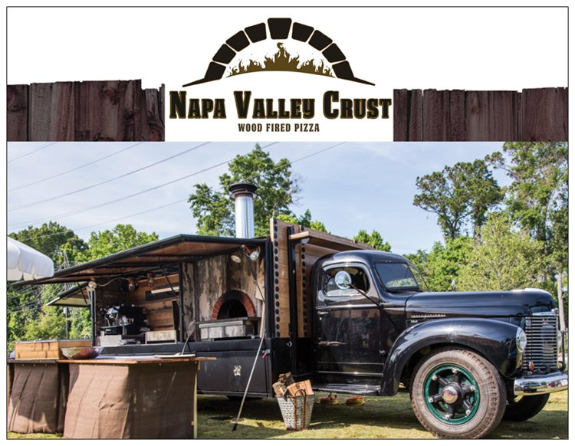
YOUR CHOICES & TOTALS…
~SELF QUOTE~
***Unlimited Food & Service for 2 hours***
***If you need 3 HRS of food and service, please ADD $5 pp ($400 MIN)***
**TRAVEL FEE MAY APPLY** All Caterings subject to 8% Tax & 20% Gratuity
**VENUE/SITE REVIEW FEE*** $75 Local (Napa Valley) and $150 Out of town
(If event is booked, we can credit Site Review FEE toward Travel charge)

PACKAGE___________________________________@ $__________ X __________#Guests = $_______________________
IF SERVING UNDER MINIMUM (less than 50p) *THE CHARDONNAY @$35 X 50p =$1750
Extras_____________________________$____________ X __________#Guests=_________________________
Extras_____________________________$____________ X __________#Guests=_________________________ Extras_____________________________$____________ X __________#Guests=_________________________

Subtotal $_____________________+TX ______________+GRATUITY______________=____________________

TRAVEL FEE - $150 (If over 15- miles from 5795 Sharp Rd. Calistoga) **___________
VENUE/SITE REVIEW- If needed -Within Napa Valley, $75 …Out of town $150 ____________

TOTAL $ ________________+TRAVEL (ONLY IF APPLIES $__________= $_____________________

GRAND TOTAL$________________-$1000 Deposit =TOTAL DUE $________________

**PAYMENT DUE AT THE EVENT, UNLESS OTER ARRANGEMENTS ARE MADE **THANK YOU!
This is a Contract between La Prima Pizza, DBA Napa Valley Crust and:
_____________________________________________________________________________________________

Guest count INCREASE changes - Please call/TXT/email NVC up to 2-3 days prior to event*
(Contracted # of guests will be the minimum charged)

Your guest head count of________guests, will be charged as your minimum.
For increment in guest count at event, NVC will make price adjustments.
We can accommodate up to 2 days prior to event if you expect more guests.
For questions/concerns please call or text BETTY at (707) 396-1579 or ALDO at (707) 396-1578
Please complete contract, sign and return via email to : laprimapizza@outlook.com
Please sign this contract to agree to La Prima Pizza/Napa Valley Crust Catering Conditions.
w-9 Available upon request. Aldo Nunez DBA La Prima Pizza DBA Napa Valley Crust
**Check payments** Please make check to NAPA VALLEY CRUST. Mail to 5795 Sharp Rd. Calistoga, CA 94515
**Credit Cards payemnts are subject to a 3% cc fee**

Name___________________________________________________________Signature___________________________________________Date__________________

NVC Will confirm receipt of you contract as confirmation of event. Receipt or confirmation of Deposit will be send.

