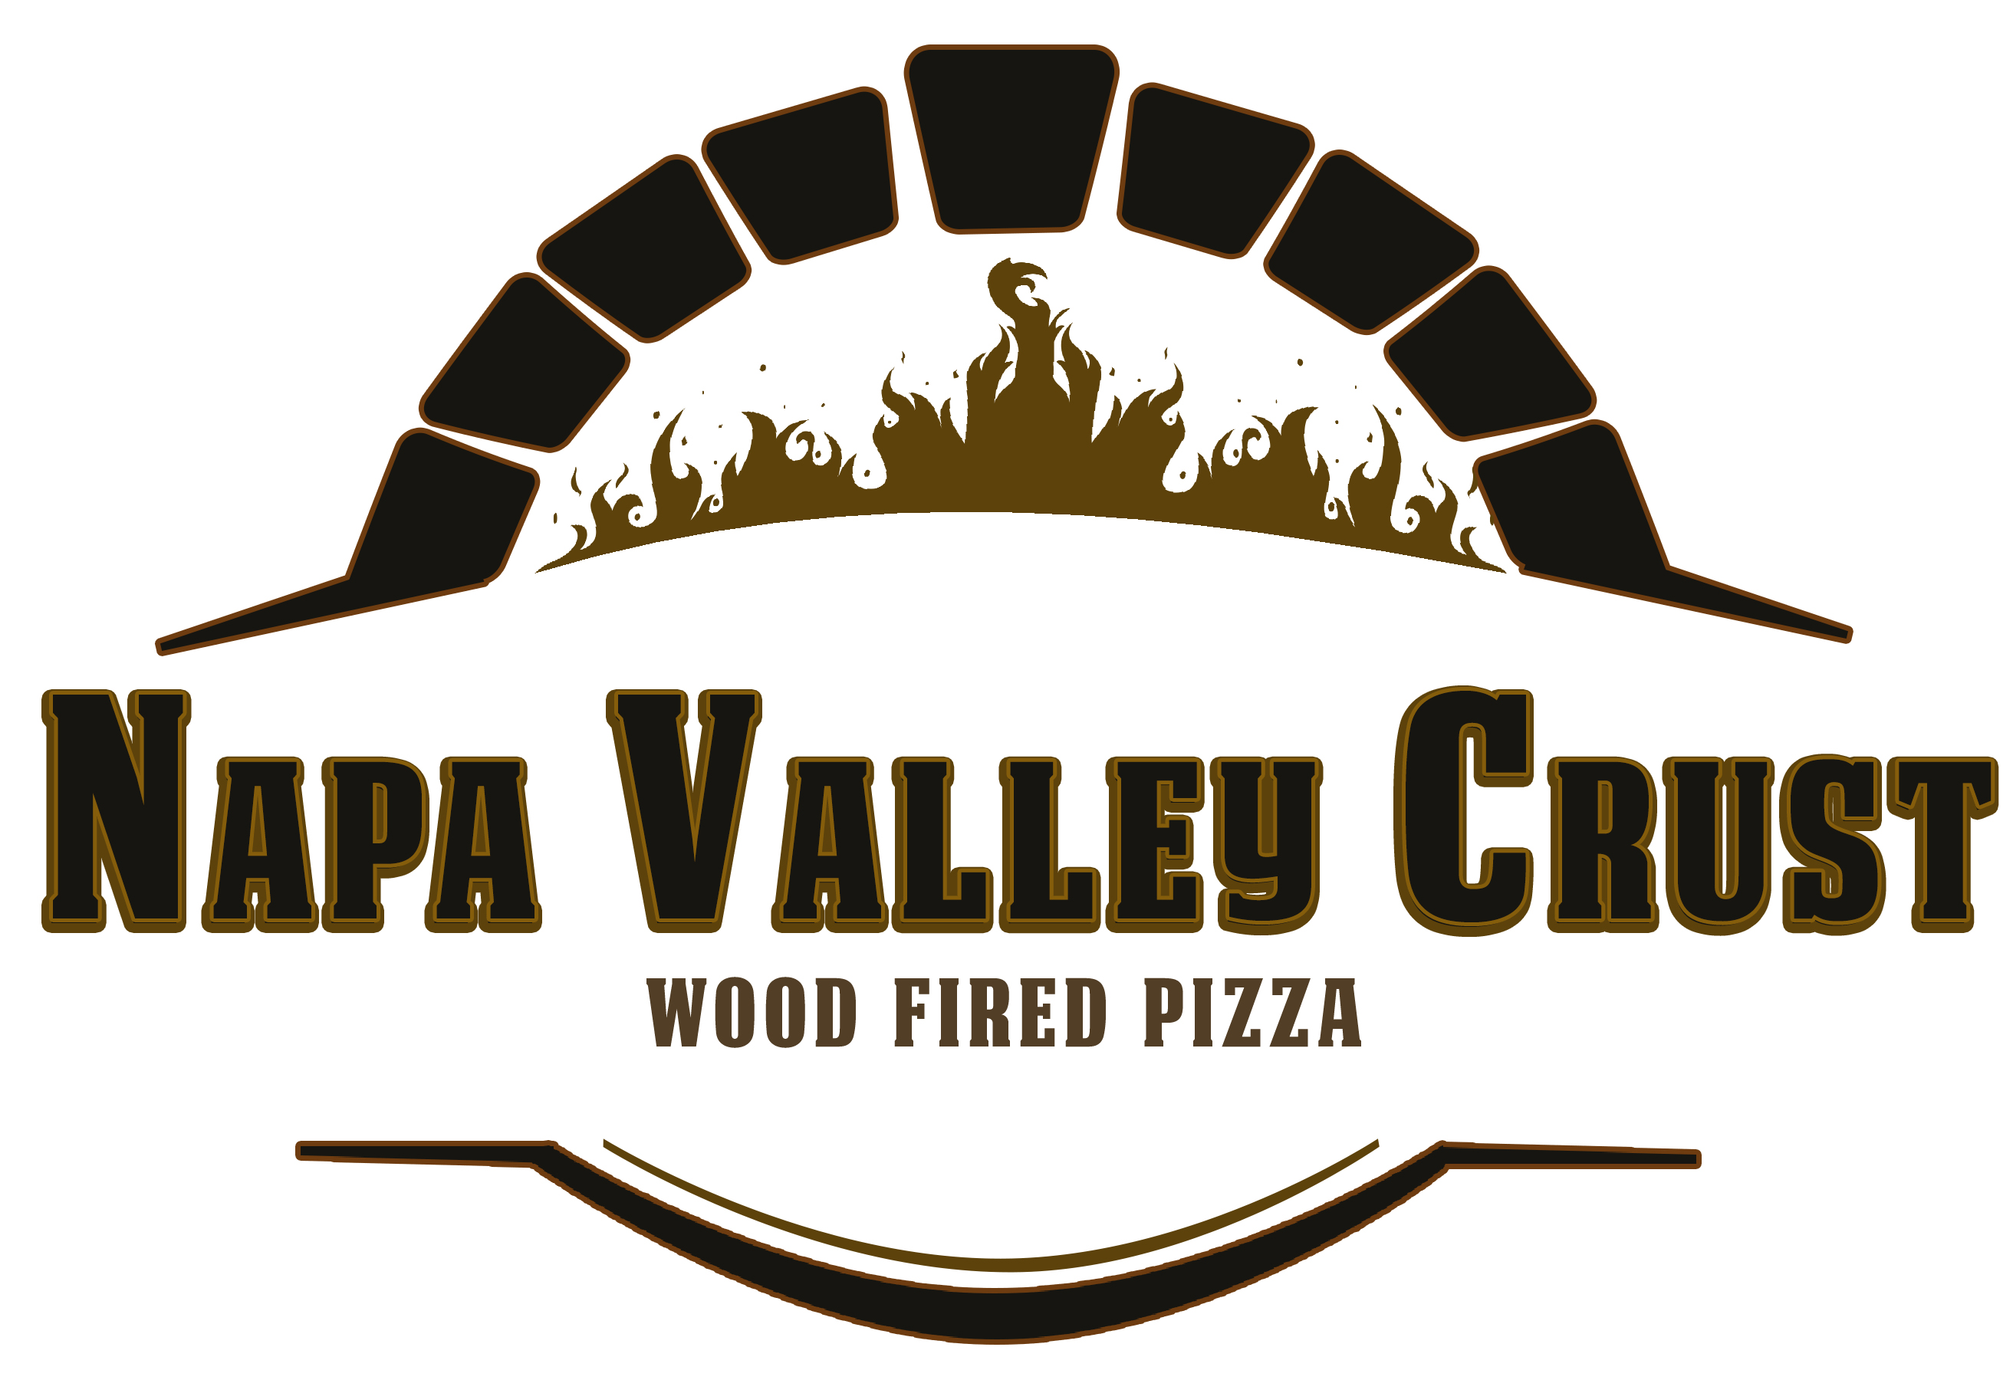
Thank you for choosing Napa Valley Crust to cater your Event!
We will set up 2 hours prior to event. We will serve for approximately 2 hours.
NVC will provide 3 tables & linen needed for a Buffet Style Service.
Price includes ALL Biodegradable Disposables (Plates, Forks, Napkins, Cups)
All Parties will include a large Jar of Infused Citrus-Cucumber Iced Water.
2 chefs and 1-2 servers included as part of our outstanding Costumer Service!
We will feature a great variety of CLASSIC & GOURMET pizzas options!
NVC will be happy to please guests’ request if any! *Gluten-free pizzas available upon request!
*Prices are subject to change when menu and options are customized!

Upgrades Available at Additional cost*
Bamboo dishware, Beer & Wine, Barista, Bar Tender…
*Coffee Service, * Refreshments * Shocked Oysters * Grill Prawns, Pasta & more….
A $500 non-refundable deposit is needed to book and reserve a date.
Please mail a check, Venmo, Zelle or provide credit card info.
8% Sales Tax will be added. 20% Service Gratuity will be added.
NVC Catering Minimum is $1200 plus tax & gratuity.
NVC as Vendor will require a $1500 minimum.

NAME_________________________________________________________________PHONE#____________________________
EMAIL__________________________________________________________________# OF GUEST______________________
EVENT ADDRESS__________________________________________________________________________________________
DATE OF EVENT__________________________________________TIME FOR SERVICE_________________________
DEPOSIT $500~C/C____________________________________________Exp_________Sec#______Zip_____________
*Extra Time* 1 Additional Hour of Unlimited Food & Service
**(Please check)___________Please Add $4pp. ($300 Minimum)

UNLIMITED BUFFET STYLE-PACKAGE OPTIONS (Please mark your selection)
**All Packages included Disposables & Infused Citrus-Cucumber Water**

- THE CHARDONNAY….. $30pp__________
Pizza & Salad Package…3-4 Classic Toppings Pizza Choices, 1 Salad!

- THE MERLOT …..$35pp___________
Pizza, Appetizer & Salad Package…..5-6 Classic Topping Pizza Choices,
1 Salad & 1 Regular Appetizer choice!

- THE RESERVE….. $40pp__________
Pizza, Salad, Appetizer & Piadini Wraps…ALL Pizza Choices,
Larger variety of Classic & Gourmet toppings, 1 Salad, Piadini, 1 Appetizer & S’mores for Dessert!

- THE WEDDING PACKAGE……..$50pp__________
The Works!!! Allow us to show off on your Special Day!
A very nice, full Buffet of ALL Pizza choices, 1 Salad, 1 Appetizer, Fresh Fruit, Cheese & Charcuterie!

WOODFIRED
CATERING
~2021 CONTRACT~

MENU, OPTIONS, PRICING…

WOOD-FIRED PIZZA!
Classic & Gourmet Toppings, Freshest Produce & Specialty Meats
Customize your own choices or Choose from our Selections!

Classic Pepperoni & Cheese-With optional Pesto or Red Sauce_____
Margherita-Mozzarella, Tomatoes, Fresh Basil, Drizzle of Balsamic glaze _____
Veggie Pesto-Roasted Veggies & pesto Sauce toped with fresh tomatoes_____
Spicy Aldo’s-Our Best Seller…Pesto, Pepperoni, Onion, Linguica & Fresh Jalapeños_____
Pesto, Garlic & Baby Clam-A popular options featuring Chef’s Clams mix_____
Garlic Chicken-White Sauce, Grilled chicken, Garlic & Red onions_____
Chicken Pesto & Roasted Corn-With Pesto Sauce, roasted Corn & grilled Chicken_____
Meat Lovers-Salami, Pepperoni, Linguica, Italian Sausage & Bacon_____
Chef’s Choice! Let the Chef show off his favorite creations!_____

***Gluten Free crust & Cheese free available upon request***

SALADS
(One Salad included with ALL Package Choices…Additional Salad @ $5pp)

Classic Caesar-Crispy Romaine Hearts with homemade croutons & Shredded Romano_____
Calistoga Salad-Organic Mixed Greens w/ Cranberries, Walnuts, Tomatoes & Balsamic_____

APPETIZERS
(One Appetizer Inlcuded in ALL Packages EXCEPT in “Chardonnay” Additional Appetizer @ $5pp)

Caprese Skewers -Fresh Mozzarella, Grape Tomatoes & Fresh basil with Balsamic Glaze....$5pp______
Buffalo Wings-Wonderful Oven-baked Chicken Wings served with our own Ranch….$5pp _____
Bruschetta Bites-Toasted Crostini with cheese & Marinated Tomatoes…,$5pp_____
Fresh Fruit Platters – Seasonal Fresh Fruit Platters….$5pp_____

SPECIALTY OPTIONS
CHARCUTERRIE, PIADINE, SHOCKED OYSTER BAR, PASTA & PR AWN-VEGGIE SKEWERS

Charcuterie, Cheese, Olives & Nuts-
Cheese & Charcuterrie, Nuts, Olives Platters- Including Crackers, Sliced bread & Grapes…. $8 ________
Piadini Bar- Thin Flat Bread Wraps w/Olive oil & garlic, Pizza topping & greens…$5________
Grilled Shocked Oyster Bar-With Avocado Aioli (Unlimited Oyster Bar)…. $10pp________
Grilled Pesto-Garlic Prawn Skewers-Grilled Roasted Veggies and Large Prawns…$10pp________
Specialty Pasta-Pasta Primavera, Tortellini Creamy Pesto or Chicken Fettuccine Alfredo…$10pp________

DESSERT
(S’mores included in THE RESERVE package only)
S’mores-Honey Cinnamon Graham cookies, Mint chocolate & chocolate/raspberry sauce! …$5pp_____

SOFT DRINKS & COFFEE & EXPRESSO SERVICE
A Variety of Soft Drinks, Lemonades & Bottle Water (ice provided)….$4pp_____
***Coffee Service***…..$5pp_____

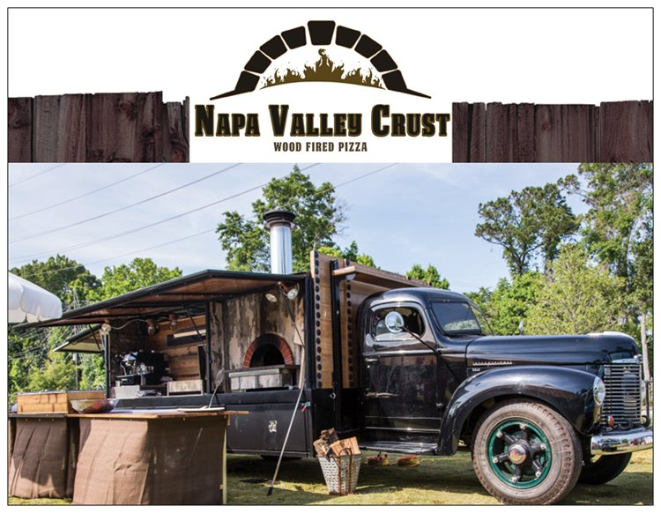
YOUR CHOICES & SUB TOTALS…

***Unlimited Food & Service for 2 hours***
***If you need 3 HRS service, please ADD $5 pp ($300 MIN)***
**TRAVEL FEE MAY APPLY** All Caterings subject to 8% Tax & 20% Gratuity

PACKAGE_____________________________@ $__________ X __________#Guests = _________________________

Extras_____________________________$____________ X __________#Guests=_________________________
Extras_____________________________$____________ X __________#Guests=_________________________ Extras_____________________________$____________ X __________#Guests=_________________________

Subtotal $_____________________+TX ______________+GRATUITY______________=_______________________

TRAVEL FEE $100-$150 (If over 15- miles from 5795 Sharp Rd. Calistoga) **___________

GRAND TOTAL ________________+TRAVEL (ONLY IF APPLIES)__________=______________________

-$500 Deposit TOTAL DUE$__________________

**PAYMENT DUE AT THE EVENT, UNLESS OTER ARRANGEMENTS ARE MADE **THANK YOU!

This is a Contract between La Prima Pizza, DBA Napa Valley Crust and:

_____________________________________________________________________________________________

Guest count INCREASE changes - Please call/TXT/email NVC up to 3 days prior to event*
(Contracted # of guests will be the minimum charged)

Your guest head count of________guests, will be charged as your minimum. For increment in guest count at event, NVC will make price adjustments.
For questions/concerns please call or text BETTY at (707) 396-1579 or ALDO at (707) 396-1578
Please complete contract, sign and return via email to : laprimapizza@outlook.com
Please sign this contract to agree to La Prima Pizza/Napa Valley Crust Catering Conditions.
**Check payments** Please make check to NAPA VALLEY CRUST. Mail to 5795 Sharp Rd. Calistoga, CA 94515
**If paying final balance with a credit card a 3% fee will be added. (No fee in the $500 deposit)

Name__________________________________________________Signature______________________________________Date_______________

NVC____________Elizabeth Nunez_____________Signature____________Elizabeth Nunez__________Date________________

